Lecture 3 (September 20, 2023)

no quiz

Hw: trading with Labels

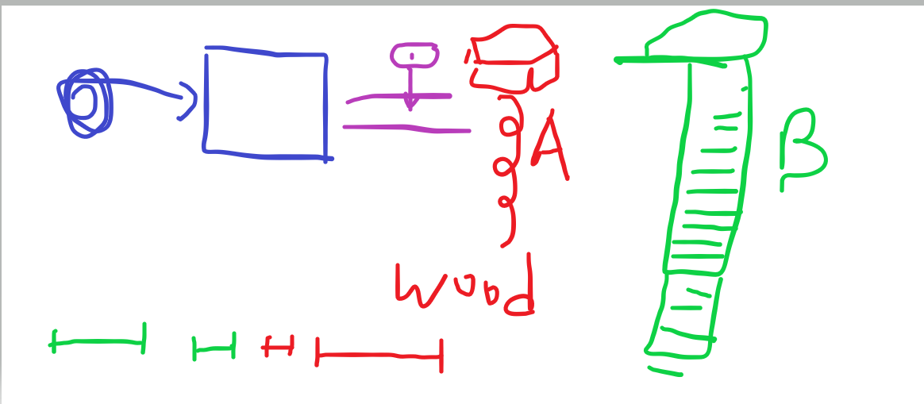

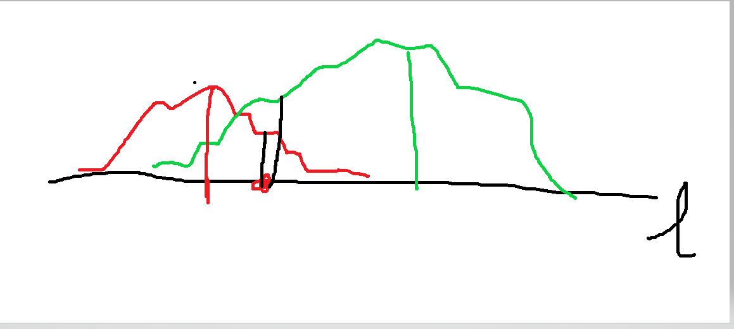

ideally, we would like a separable space

in practice, this is not possible

One way is to transform the input data into another representation

e.g x---🡪(x, x\*\*2)

